EXCEL UPLOAD USING PHP

1.IF YOUR SYSTEM DOESN’ HAVE “COMPOSER” YOU WANT TO DOWNLOAD IT FROM BROWSER,

2.AND OPEN “COMMAND PROMPT” AND CHECK WHETHER THE “COMPOSER” IS DOWNLOADE OR NOT,

3.AND CHANGE THE PATH OF A DOWNLOADED COMPOSER TO YOUR RECENT PROJECT PATH AND ALSO DOWNLOAD THE PHP SPREADSHEET IN COMMAND PROMPT,

4.excel/dbconfig.php:

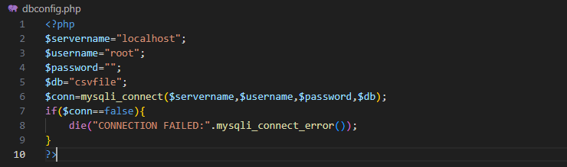

5.excel/index.php:

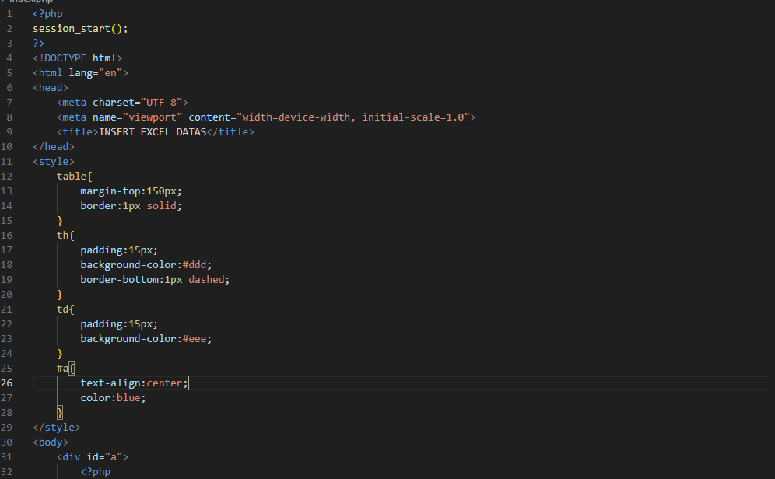

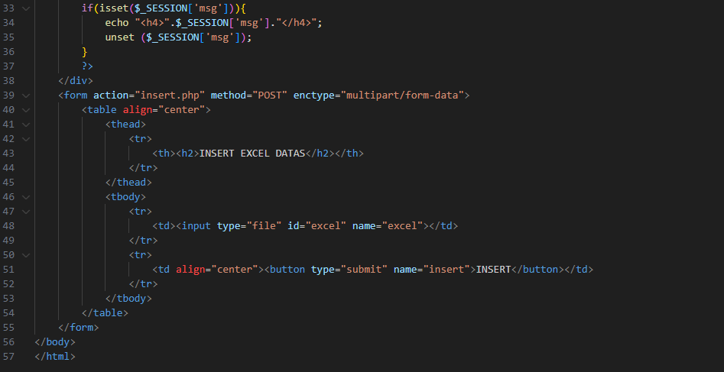

6.excel/insert.php:

